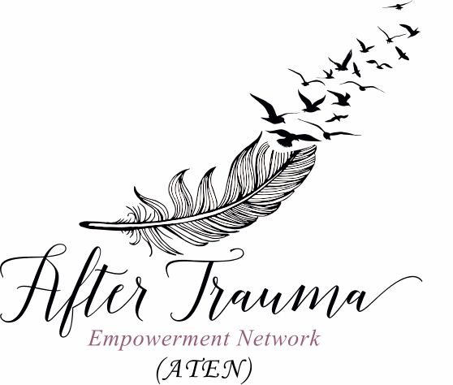
COMMUNITY HEROES QUILT
ORDER FORM

Name:
Address:
Phone:
Email:
I would like to purchase:
☐ Square $ 50.00
☐ Heart $150.00
Method of Payment:
☐ Cash ☐ E-transfer (info@atenns.ca)
☐Debit ☐Cheque
Name to be placed on quilt:

Email completed order form to info@atenns.ca
Thank You for Your Generous Support!!!

